**Lab 6: Updating and Deleting Record**

**Code:**

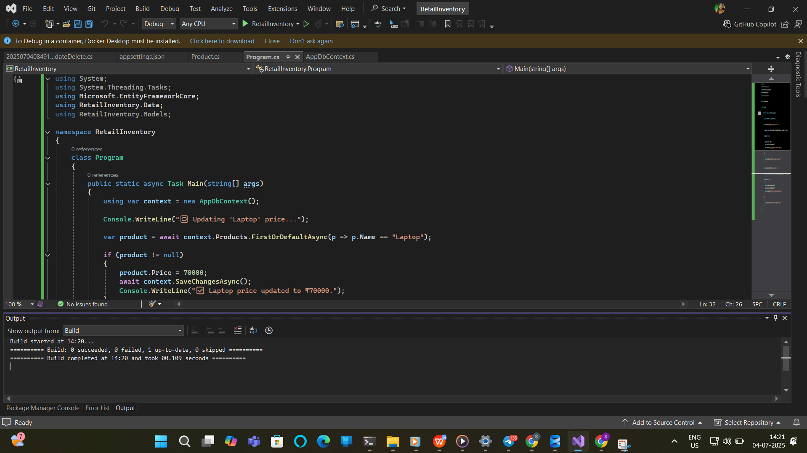

**Output:**

